Year | Name of teacher | Name of conference / workshop attended for which financial support provided | Name of the professional body for which membership fee is provided | Amount of support received (in INR)
2017-18 | Nil | Nil | Nil | Nil
2018-19 | Nil | Nil | Nil | Nil
2019-20 | Nil | Nil | Nil | Nil
2020-21 | Nil | Nil | Nil | Nil
2021-22 | Nil | Nil | Nil | Nil
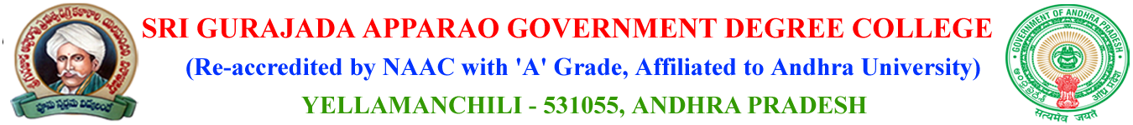

6.3.2 Percentage of teachers provided with financial support to attend conferences/workshop and towards membership fee of professional bodies during the last five years.

